**Automatic Tablet Counting and Bottling Control System using PIC Microcontroller**

**Introduction:**

In pharmaceutical companies, the tablets are filled in bottles and all the bottles are required to be filled equally by tablets. And in the end total number of bottles are counted and they are grouped in the form of batches. In one day, thousands of bottles are filled and packed so it is almost impossible for human to count number of tablets in each bottle and total number of bottles filled and keep check and balance on them. Here the role of automatic tablet counting and bottling control systems arises.

**Block Diagram:**

16x4 LCD Display

PIC16f877A

Keypad(4x4)

For entering total number of tablets per bottle

Sensor for detecting tablets

L293 motor drive

Motor for running Conveyor belt upon filling of bottle

Button for changing settings

**Objective:**

The objective of the project is that to reduce human effort, concentration and human error as it becomes totally impossible to count thousands of bottles and total number of tablets in bottle so to create the effective working ,removing human error and implementing project with cost effective method is the objective of this project. Nowadays all the pharmaceutical industries in world are using just like this or more advanced system than this.

**Circuit Diagram:**

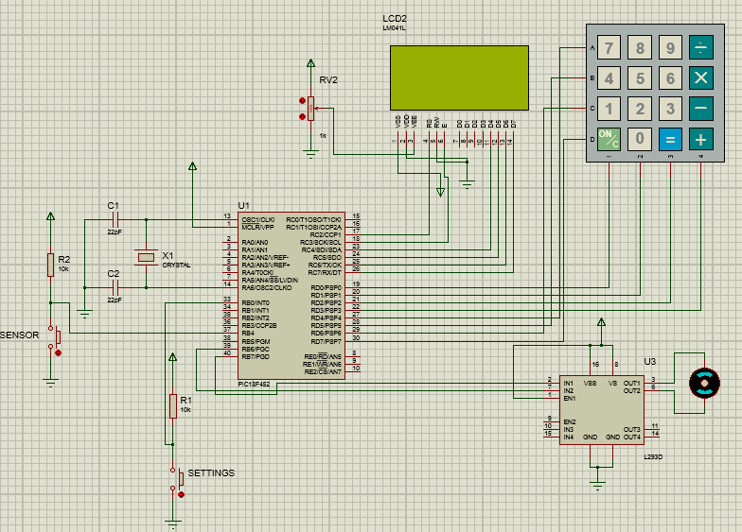

**Overall working:**

In start the number of tablets to be filled in each bottle are entered by the user and this constant value is stored and displayed on the LCD display. After that the tablets starts going in the bottle and sensor keeps detecting the tablets and controller keeps adding these counts and these are updated frequently on the LCD. When these counts becomes equal to the predefined quantity the tablets stops to go to bottle and at this time conveyor starts and keeps running until new bottle arrives and in the last these counts are summed and show on the LCD display as total. This process keeps repeating.

If we want to change the number of tablets per bottle then we have to enter in system settings. So, for changing system settings we have to enter the password and admin name. These admin name and password are stored in eeprom and when the user enters the correct admin name and password then he can change the amount of tablets per bottle. And this fix number is also stored in eeprom.

**Main components:**

The main components of the system are controller which is PIC16f877A , one Hex keypad,L293 Motor Drive, motor for conveyor belt, IR sensor, decoder ,7 segment display and small basic components like resistor capacitors and other things.

**4x4 Keypad Module:**

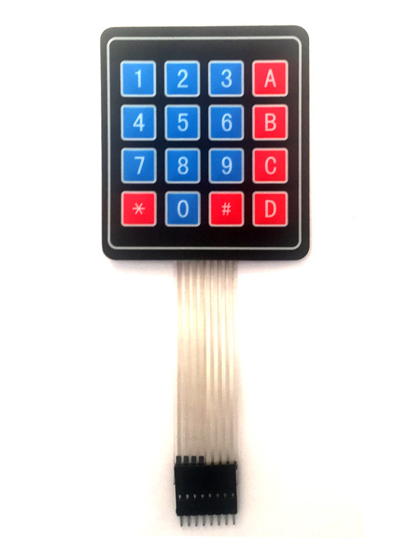

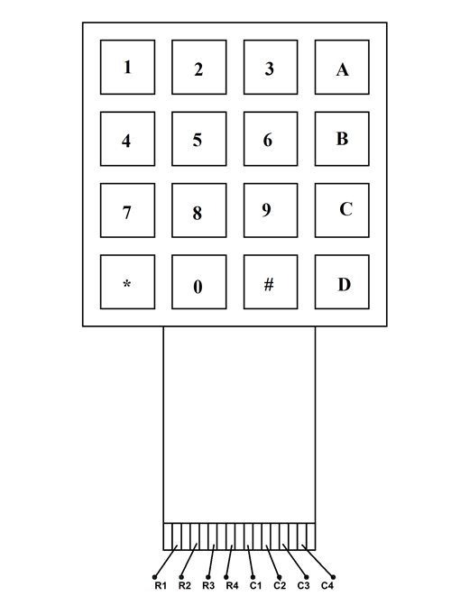

**4X4 KEYPAD Pin Configuration:**

4X4 KEYPAD MODULES are available in different sizes and shapes. But they all have same pin configuration. It is easy to make 4X4 KEYPAD by arranging 16 buttons in matrix formation by yourself.

|  |  |
| --- | --- |
| **Pin Number** | **Description** |
| **ROWS** | |
| 1 | PIN1 is taken out from 1st  ROW |
| 2 | PIN2 is taken out from 2nd  ROW |
| 3 | PIN3 is taken out from 3rd  ROW |
| 4 | PIN4 is taken out from  4th ROW |
| **COLUMN** | |
| 5 | PIN5 is taken out from 1st  COLUMN |
| 6 | PIN6 is taken out from 2nd  COLUMN |
| 7 | PIN7 is taken out from 3rd  COLUMN |
| 8 | PIN8 is taken out from 4th COLUMN |

As given in above table a 4X4 Keypad will have eight terminals. In them four are Rows of matrix and four are columns of matrix. These 8 PINS are driven out from 16 buttons present in the MODULE. Those 16 alphanumeric digits on the MODULE surface are the 16 buttons arranged in MATRIX formation.

**Contribution in Project:**

The keypad will be used as the input source for setting number of tablets to be filled in each bottle.For example if we want to put 6 number of tablets in each bottle then this keypad will use for setting input.

# **DC Motor and**[**L293D**](https://electrosome.com/l293d-quadruple-half-h-dc-motor-driver/)**:**

We can’t drive a DC Motor (depends) directly with a Microcontroller, as DC Motors requires high current and high voltage than a Microcontroller can handle. Microcontrollers usually operates at +5 or +3.3V supply and it I/O pin can provide only up to 25mA current. Commonly used DC Motors requires 12V supply and 300mA current, moreover interfacing DC Motors directly with Microcontrollers may affect the working of Microcontroller due to the Back EMF of the DC Motor. Thus it is clear that, it not a good idea to interface DC Motor directly with Microcontrollers. The solution to above problems is to use H-bridge circuit.

[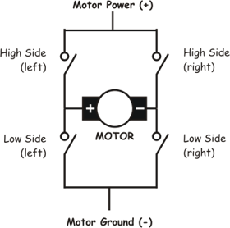](https://electrosome.com/wp-content/uploads/2012/06/basic-bridge.gif)

It is a special circuit, by using the 4 switches we can control the direction of DC Motor. Depending upon our power requirements we can make our own H-bridge using Transistors/MOSFETs as switches. It is better to use ready made ICs, instead of making our own H-bridge.L293D and [L293](https://electrosome.com/l293d-quadruple-half-h-dc-motor-driver/) are two such ICs. These are dual H-bridge motor drivers, ie by using one IC we can control two DC Motors in both clock wise and counter clockwise directions. The L293D can provide bidirectional drive currents of up to 600-mA at voltages from 4.5 V to 36 V while [L293](https://electrosome.com/l293d-quadruple-half-h-dc-motor-driver/) can provide up to 1A at same voltages. Both ICs are designed to drive inductive loads such as dc motors, bipolar stepping motors, relays and solenoids as well as other high-current or high-voltage loads in positive-supply applications. All inputs of these ICs are TTL compatible and output clamp diodes for inductive transient suppression are also provided internally. These diodes protect our circuit from the Back EMF of DC Motor.

[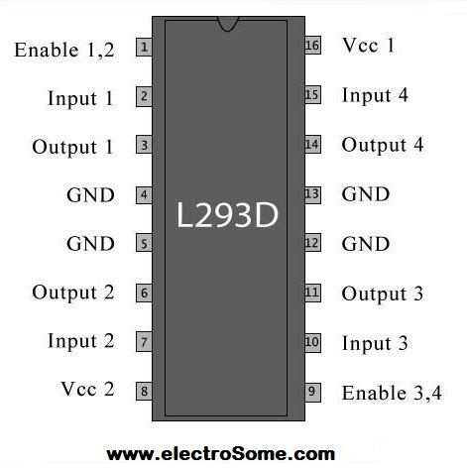](https://electrosome.com/wp-content/uploads/2012/06/L293D-pin-out.jpg)

In both ICs, drivers are enabled in pairs, with drivers 1 and 2 are enabled by a high input to 1,2EN and drivers 3 and 4 are enabled by a high input to 3,4EN. When drivers are enabled, their outputs will be active and in phase with their inputs. When drivers are disabled, their outputs will be off and will be in the high-impedance state.

**Contribution in Project:**

Motor drive and motor are essential part of this circuit. The motor is used to move conveyor belt and as we know controller can not run the motor dirrectly so for controlling motor motor drive is used.

**PIC18F452 Controller:**

The PIC microcontroller **PIC18f452** is one of the most renowned microcontrollers in the industry. This microcontroller is very convenient to use, the coding or programming of this controller is also easier. One of the main advantages is that it can be write-erase as many times as possible because it uses **FLASH memory technology**. It has a total number of 40 pins and there are 33 pins for input and output. P**IC18f452** is used in many [pic microcontroller projects](https://microcontrollerslab.com/pic-microcontroller-projects-for-eee-students/). P**IC18f452** also have much application in digital [electronics circuits](https://microcontrollerslab.com/electronics-projects/).

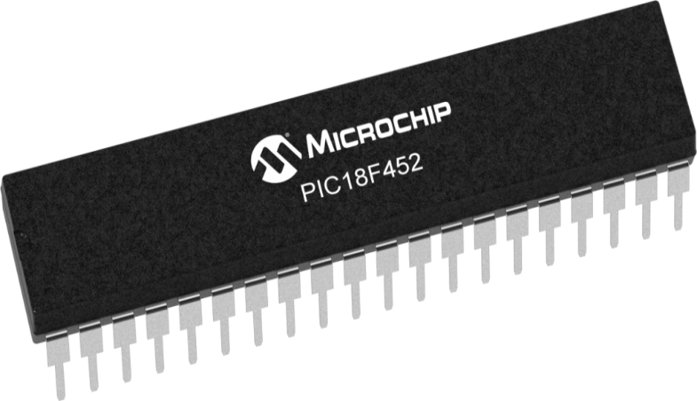

PIC18F452 finds its applications in a huge number of devices. It is used in remote sensors, security and safety devices, home automation and many industrial instruments. An[EEPROM](https://microcontrollerslab.com/eeprom-working-interfacing-with-microcontroller/) is also featured in it which makes it possible to store some of the information permanently like transmitter codes and receiver frequencies and some other related data. The cost of this controller is low and its handling is also easy. It is flexible and can be used in areas where microcontrollers have never been used before as in microprocessor applications and timer functions etc.

* It has a smaller 35 instructions set.
* It can operate up to20MHz frequency.
* The operating voltage is between 4.2 volts to 5.5 volts. If you provide it voltage more than 5.5 volts, it may get damaged permanently.
* It does not have an internal oscillator like other [PIC18F46K22](https://microcontrollerslab.com/pic18f46k22-microcontroller-introduction/), [PIC18F4550](https://microcontrollerslab.com/introduction-pic18f4550-microcontroller/).
* The maximum current each PORT can sink or source is around 100mA. Therefore, the current limit for each GPIO pin of PIC18F452 is 10 mili ampere.
* It is available in four IC packaging such as 40-pin PDIP  44-pin PLCC, 44-pin TQFP, 44-pin QFN

**Contribution in Project:**

This component is the heart of the circuit. All the input output processes,driving motor ,counting tablets,shownig on the seven segment and many other things are done by this controller.

### ****Brief about IR Sensor Module:****

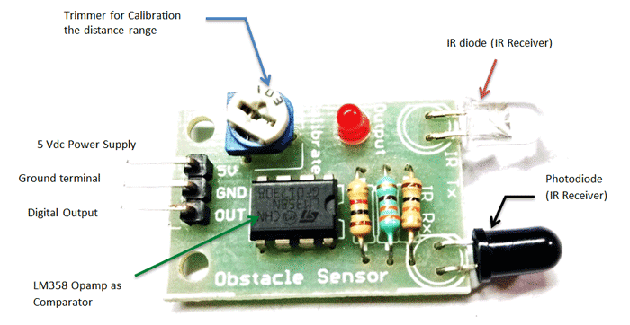

The IR sensor module consists mainly of the IR Transmitter and Receiver, Opamp, Variable Resistor (Trimmer pot), output LED in brief.

**IR LED Transmitter**

[IR LED](https://components101.com/ir-led-pinout-datasheet) emits light, in the range of Infrared frequency. IR light is invisible to us as its wavelength (700nm – 1mm) is much higher than the visible light range. IR LEDs have light emitting angle of approx. 20-60 degree and range of approx. few centimeters to several feets, it depends upon the type of IR transmitter and the manufacturer. Some transmitters have the range in kilometers. IR LED white or transparent in color, so it can give out amount of maximum light.

**Photodiode Receiver**

Photodiode acts as the IR receiver as its conducts when light falls on it. Photodiode is a semiconductor which has a P-N junction, operated in Reverse Bias, means it start conducting the current in reverse direction when Light falls on it, and the amount of current flow is proportional to the amount of Light. This property makes it useful for IR detection. Photodiode looks like a LED, with a black color coating on its outer side, Black color absorbs the highest amount of light.

**Contribution in Project:**

This component is the responsible for detecting the dropping of tablets in the bottle.Every time the tablet moves from stopper to bottle the sensor detects and sends signal to the controller and controller counts the tablet according to it.

## **16×4 LED:**

The term [LCD stands for liquid crystal display](https://www.elprocus.com/difference-alphanumeric-display-and-customized-lcd/). It is one kind of electronic display module used in an extensive range of applications like various circuits & devices like mobile phones, calculators, computers, TV sets, etc. These displays are mainly preferred for multi-segment [light-emitting diodes](https://www.elprocus.com/light-emitting-diode-led-working-application/) and seven segments. The main benefits of using this module are inexpensive; simply programmable, animations, and there are no limitations for displaying custom characters, special and even animations, etc.

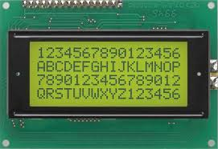

### LCD 16×4 Pin Diagram:

The 16×4 LCD pinout is shown below.

* Pin1 (Ground/Source Pin): This is a GND pin of display, used to connect the GND terminal of the microcontroller unit or power source.
* Pin2 (VCC/Source Pin): This is the voltage supply pin of the display, used to connect the supply pin of the power source.
* Pin3 (V0/VEE/Control Pin): This pin regulates the difference of the display, used to connect a changeable POT that can supply 0 to 5V.
* Pin4 (Register Select/Control Pin): This pin toggles among command or data register, used to connect a microcontroller unit pin and obtains either 0 or 1(0 = data mode, and 1 = command mode).
* Pin5 (Read/Write/Control Pin): This pin toggles the display among the read or writes operation, and it is connected to a microcontroller unit pin to get either 0 or 1 (0 = Write Operation, and 1 = Read Operation).
* Pin 6 (Enable/Control Pin): This pin should be held high to execute Read/Write process, and it is connected to the microcontroller unit & constantly held high.
* Pins 7-14 (Data Pins): These pins are used to send data to the display. These pins are connected in two-wire modes like 4-wire mode and 8-wire mode. In 4-wire mode, only four pins are connected to the microcontroller unit like 0 to 3, whereas in 8-wire mode, 8-pins are connected to microcontroller unit like 0 to 7.
* Pin15 (+ve pin of the LED): This pin is connected to +5V
* Pin 16 (-ve pin of the LED): This pin is connected to GND.

**Contribution in Project:**

Lcd is showing the number of tablets in each bottle to be filled,current tablets in bottle,totol tablets uptil now and for showing system change info like entering password,admin name, and number of tablets in each bottle.

**Simulation Results:**

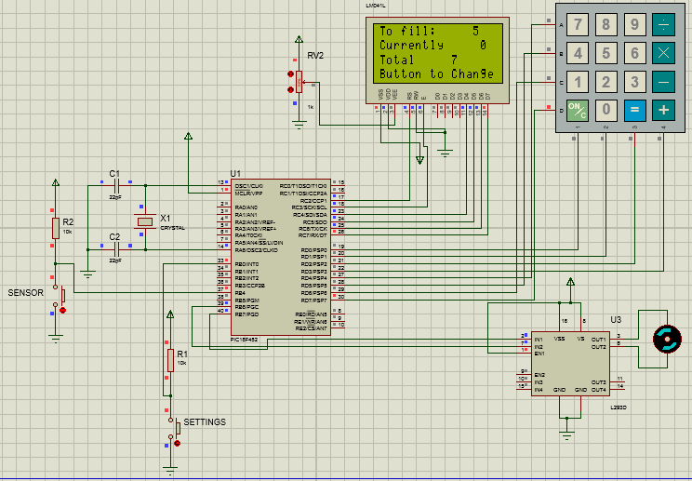

When number of tablets in bottle becomes equal to the predefined qantity then motor starts for 500ms and the total becomes total+count and current count becomes zero.

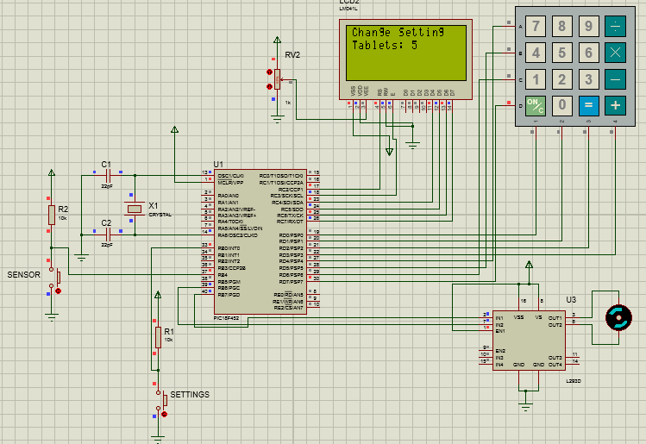

After entering correct password and admin name the system settings like tablets quantity are being change.

**Possible Application domains:**

The possible application domain of this project are:

* Pharmaceutical Industries
* Warehouses
* Any general industry having common counting system